Stage 1
In this stage, I will start off by making the base mechanics of the game. This includes:
- Basic movement controls (w, a, s, d, spacebar, etc)
- Collisions
- World side scrolling camera on movement
  - Player is centre locked
  - When moving in a direction, the objects on screen are moved relative to the player’s movement, if a boundary Is nearby, and the player moves toward boundary, the camera doesn’t exceed the boundary.
- Some game states including:
  - Menu on startup
  - Settings button + settings
  - Quit button that ends the game
- Respawning + live/health system
- Dynamic obstacles

Character creation:
I started this off by making a separate file that I will import as a module because by keeping all classes in one file, it keeps my overall code organised and easy to manage.

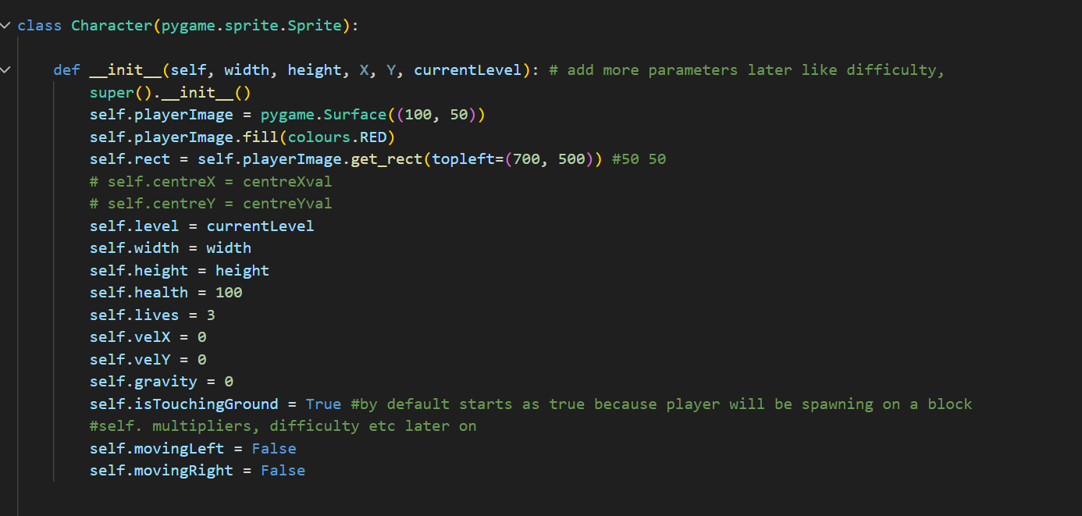

First of all I define the variable I know I am going to need for sure. This makes programming the character’s functionality easier.
My first error with this is when I initially tried to draw the player on to the screen. I did this initially by just using the pygame’s feature of drawing a rectangle. The issue with this is that this rectangle was separate from the actual rectangle that was controlling the player’s behaviour, i.e the hitbox for collisions.I fixed this by using the blit() method because this draws on the rectangle I made in the attributes of the initialisation.

Bug with collisions
While making the collisions for each platform my player can interact with, like standing on, going into, I ran into an error that caused my player to either do one of the two: horizontal collisions work but vertical don’t so for example standing on top of a block, when I move I get teleported to the side, or vice versa where ifI try to go into the side of a block, I phase right through it. This is because horizontal and vertical collisions need to be handled separately, and with up to date information on the player’s position. By separating them, this prevents the two collision detections from overlapping with each other. And also ensures that the position of the player used to calculate and detect collisions is up to date and doesn’t cause issues. This can be done by redefining the group of objects my player collides with after each directional collision check, and I separated the two collision checks by just running the horizontal checks first, then the vertical.

Before:
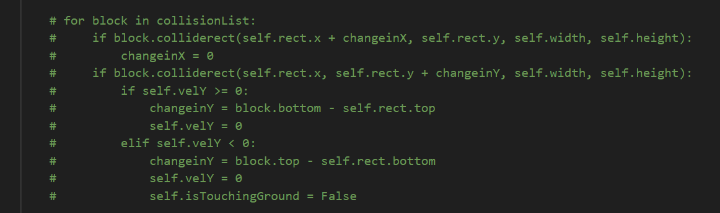

^ The collisions are all done in the same loop so the bug occurs

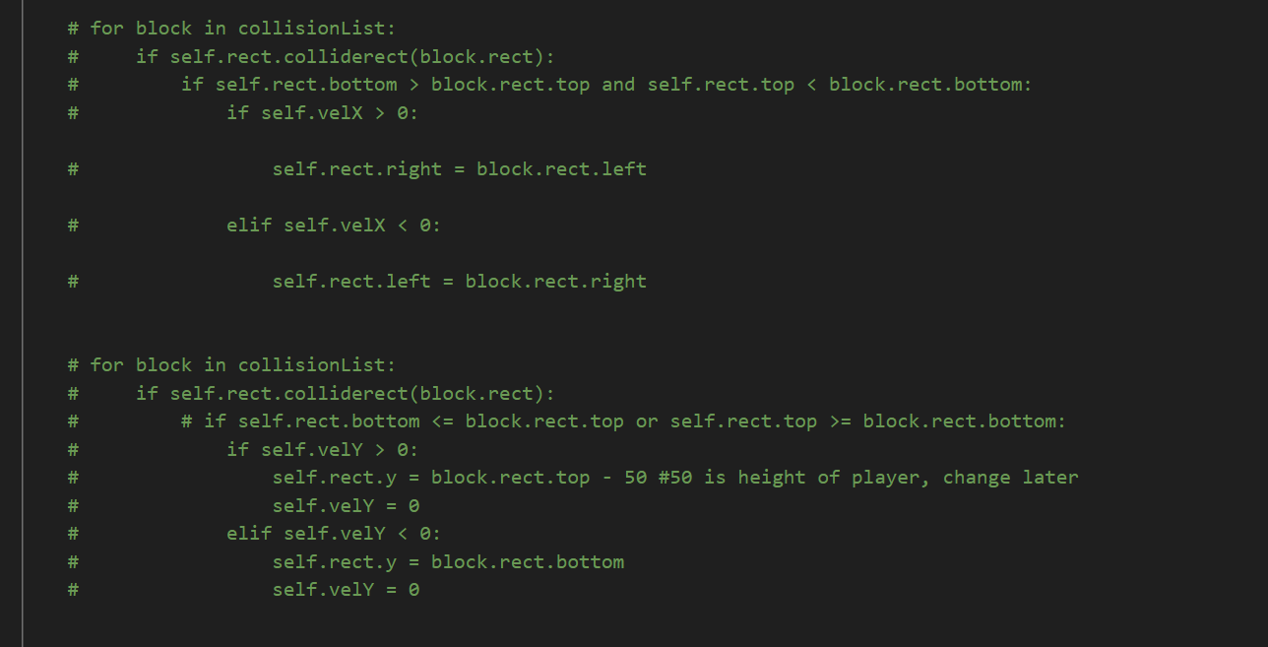

After: 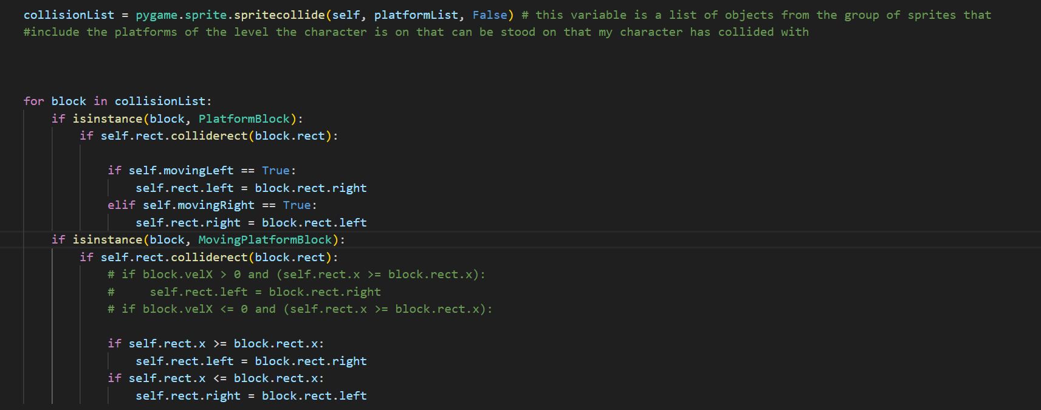
Horizontal checks ^
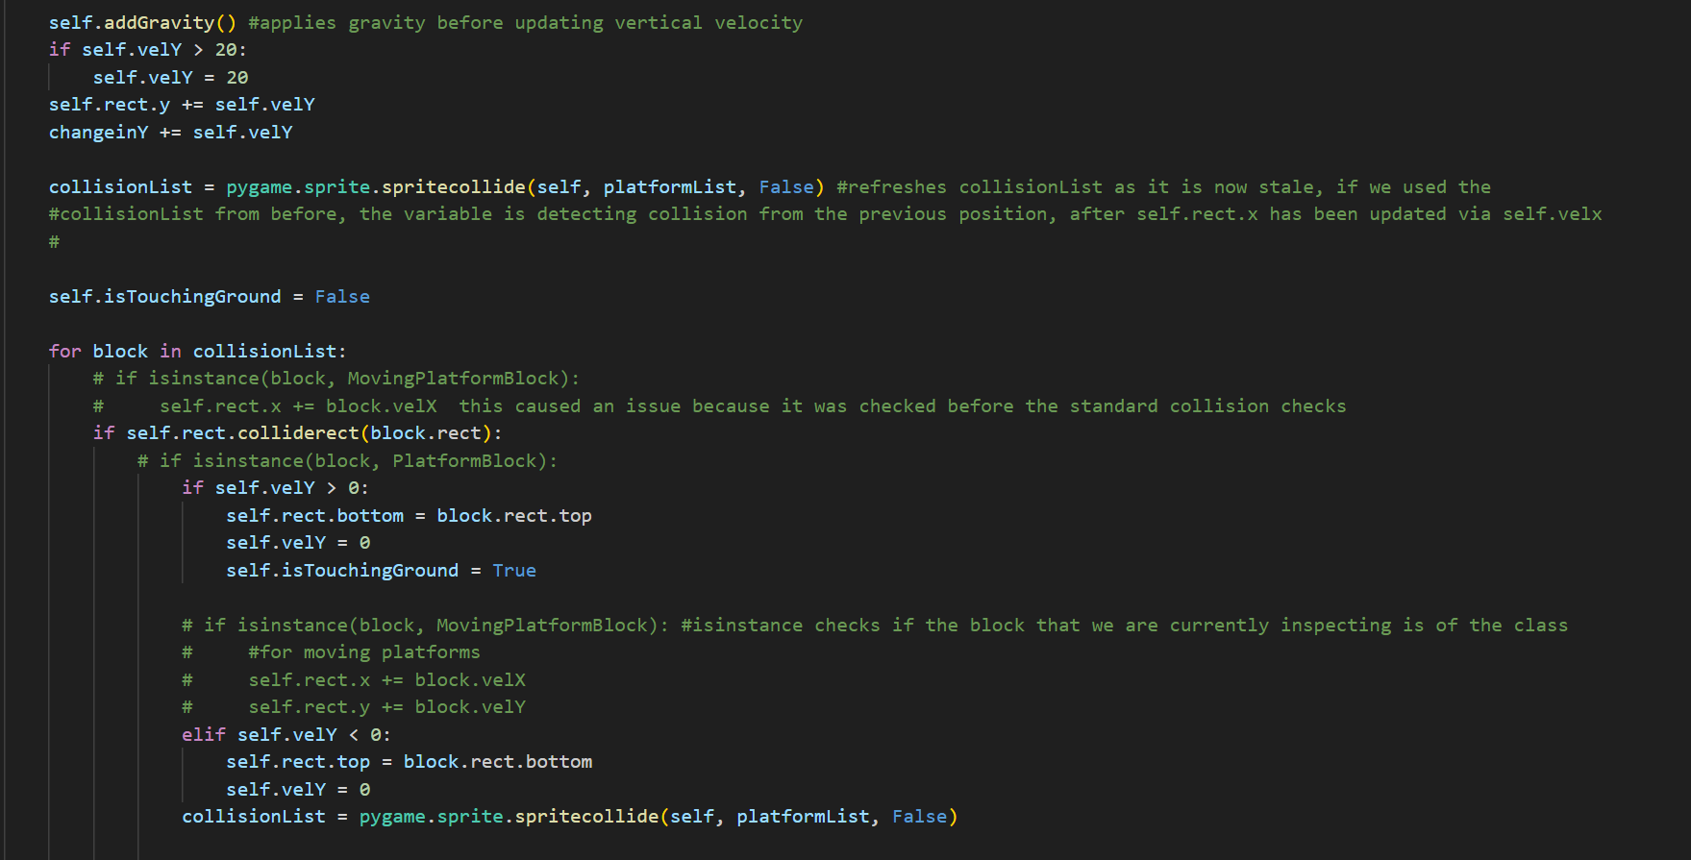
Vertical checks ^ done entirely in a separate loop

Bug with importing modules (circular import):
While first trying to understand how to use modules, I made the mistake of importing a module into another one, and vice versa at the same time. This results in something called a circular import. What this means is that because when you import something, it first runs everything in in the module that was imported, it means you cannot use anything from the file you have imported into before the module that was imported because the code would not have been run yet. So for example in my main game file I used something from the module I imported from, but in that module I imported the main game, meaning since the main game has something that uses my module, and then it has been imported into the module, since somethings may have not yet been defined during run time, then we have an error because the code does not know what the undefined variables or functions are.

In classes file:
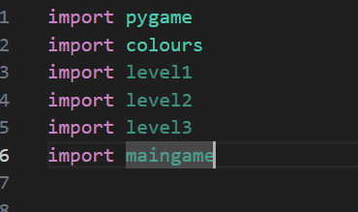

In main game file:
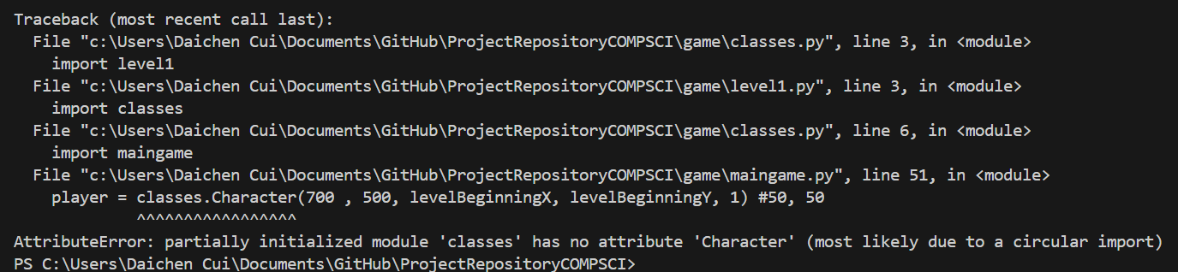

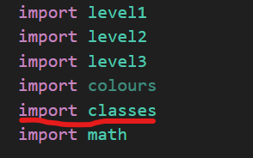

Gravity error:
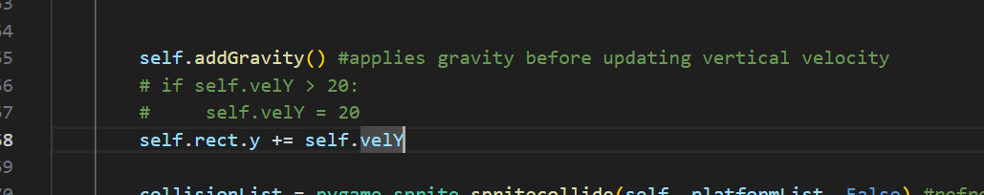
This piece of code in blue shows the original code that was used to calculate gravity. The issue with this is that it makes it so when the player falls, the longer they fall the faster they fall for an indefinite amount of time so there is no terminal velocity. At the time of this code being made there was not yet any boundary conditions that make sure gravity doesn’t drag you down while you are touching ground, because what this would do is that since it continually adds gravity, sometimes it would make jumping not work as the downwards velocity would be so high, and this would also often result in you falling through the ground because eventually your velocity would be so high the game couldn’t store it and the code just breaks.

The part in comments is the solution, by making a limit for how high the downward velocity can be, it acts as a boundary condition. This is also a secondary boundary condition to prevent falling through the ground for later one when I add actual boundary conditions to ensure that I don’t fall through platforms.

Jump implementation / fix:
Making the jump mechanic simply requires a quick input detection, then just changing the vertical velocity to decrease (as in pygame going up means to decrease y position), however the issue with this is that we can jump infinitely and this is unrealistic for the game because it would make it too easy. To prevent this I needed a boundary condition that also happened to prevent the falling through bug prior to this.

The value chosen for the gravity was picked just from testing what I thought would work, the value is mostly just random.

Moving block collisions / velocity bug:
Initially I thought of making an entire separate method that detects for collisions only if you are in contact with an instance of the class for moving platforms. This however is inefficient as I can just include it into my main update method for the player. By simply adding an extra conditional that needs to be check so the the collision detection code can tell which set of collision checks to use
In horizontal collision loop:
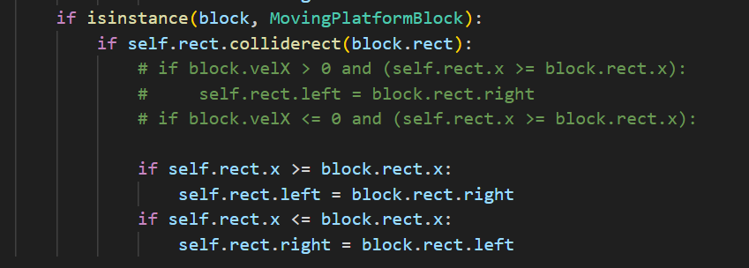
In vertical collision loop:

While doing this, I ran into an error where whenever my player stands on the top of any moving platform, although the game does update my x position, it does so incorrectly as it does it too slowly, meaning it isn’t adding up enough velocity to my player has enough, so I just doubled the rate at which my velocity is updated when on the block to get to the platform and player to update velocity at the same rate.
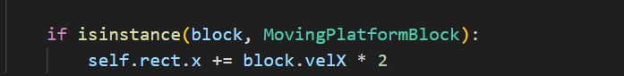

World scroll / moving camera bug:
The first bug I encountered while trying to make a moving camera that follows your player around so I can make larger level designs that exceed the player’s devices’ resolution is when the objects on screen were moving in the opposite direction of the player’s movement (correct bit) at a rate that wasn’t accurate to the actual positions of the objects (error part). Sometimes for example, you would see the player walking on thin air or inside a block and collision not kicking in, this isn’t the issue of the collisions but rather the way everything in the game was drawn. This also made it so the character on screen, the camera would not be following it fast enough and the player could still go off screen. This was due to cameraoffset values having only been applied to platforms and objects. But in reality you have to apply the offset to everything that needs to be drawn otherwise the ones that don’t have a corrected offset will appear out of place; their hitboxes will still be in the right position but in the main game screen, it would look like they are out of place and you could walk onto air.
Fixing this just required me to add offset to every drawn object.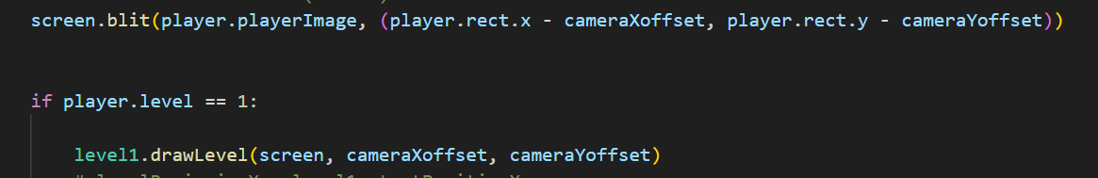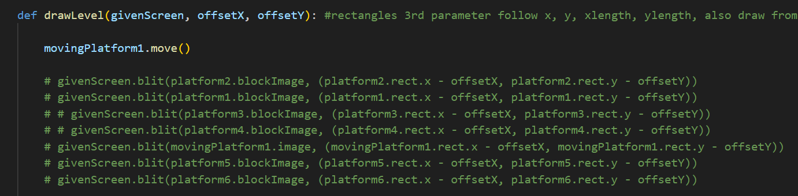

Drawing revamp>

While working on this solution, I noticed that the code for drawing objects that are in the level design onto the screen is very inefficient because if I was to make a large map design for the level, I would have to copy tens of lines of code to just draw them, I refined this by running a loop that goes through the group that consist of all platforms on the level, and drawing each iteration through the group.

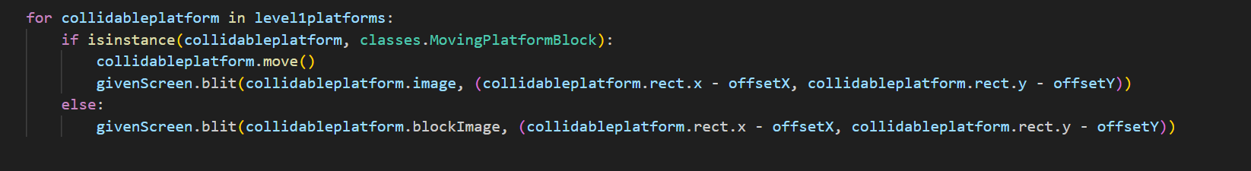

An alternative method I found was to use the method draw() directly on the group of objects, however this caused some issues that I wasn’t able to figure out what it meant by at the time, I also chose not to use this method because in the case that I would need to make changes to how certain objects are drawn, it would be harder to do so whereas with the for loop way I can make this adjustment much easier by just including it as an extra conditional in the for loop.



Menu screen bug
While implementing the menu screen, I noticed that the buttons for my menu screen have their texts displayed twice
(The image below uses a random place holder image, I was just testing if loading an image for the menu background works)
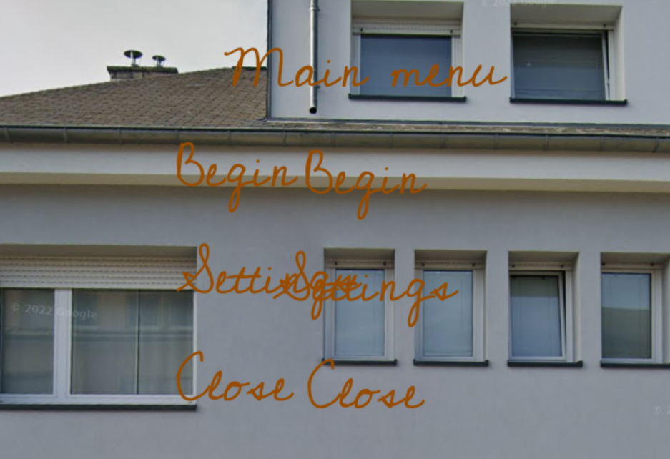

(still working on this one)

Background in game scroll
I wanted to add a background setting that changes on each level and also whenever you move, the background is an infinitely refreshing background the moves relative to your position to 1. Give the player an idea of the difficulty of the level 2. Give the game an ambience and some detail. The first issue I got with this was that whenever I moved, the background always scrolled to the left, even if I start moving to the left, which doesn’t make sense because if you have mountains on the background, you should expect them to move to the left out of view if you move to the right and vice versa if you move to the left.

Originally
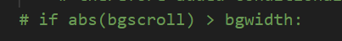

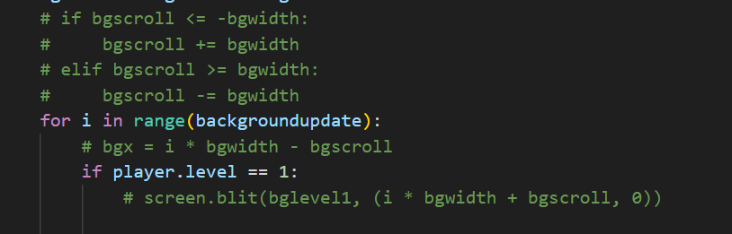

After fix:
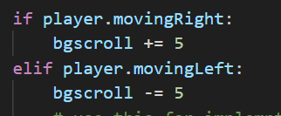
Replaced first image block of code

And
Replaces the second block of code

The thought process behind the first code was that if I did absolute value, regardless moving left and right, I could take that value, make a conditional then add or subtract the value depending on if you move left or right, however the issue with this is since if you move out of bounds (the out of bounds area is considered to be outside the original box / field of view when you first spawn in, by the game) the scroll will always be larger than the bgwidth, so the code always runs in the second block even if you stop moving. To fix this, by using the second block of code in the fixed section, by applying modulus, I can make the game know how much to move the background image by, without worrying about the width boundaries, as the modulus, since the bg scroll always has a factor of 5, if you mod it, the result will cycle through 0 mod 5, 1 mod 5, 2 mod 5, 3 mod

5, and 4 mod 5, so these 4 numbers will only be the results and we therefore have a boundary made (0, 1, 2, 3, 4)

Menu screen buttons error
While making the button class for my menu screen and interactivity options like opening settings, I encountered a simple bug / syntax error where while trying to create an instance of a button, I passed None as the image parameter for my buttons, I did this because I thought if I made an actual button image / outline for each button, i.e menu button, setting button, it would take up too much space of the game screen, so I thought if I just put down None, only the text will be written onto the screen and you can click the text to return to menu or go to settings. However when I define the class, I forgot that I had an attribute that uses the get_rect() method to get a rectangle out of the image parameter so I can perform mouse collision checks for later on.
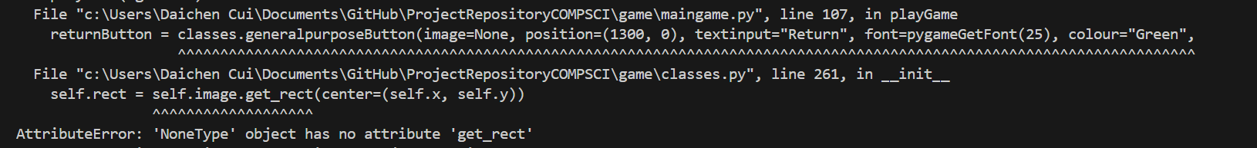
What I learnt from this is that whenever you initialise a class’s attributes, I need to keep in mind that when I am passing arguments for creating an instance of the class, the arguments must all be in some form that will be applicable to the class. I.e in this case, since I know I used the get_rect() method somewhere in the class, I need to keep in mind that the parameter that uses it, when I am passing a value, I need to provide a value that the block of code can work with, meaning None will not work because it isn’t a rectangle, so you cant get a rectangle hitbox out of it, whereas with an image you can.

